Experiment: 10
5G Network Slicing Environment Using MATLAB
Aim
To analyze the performance of a 5G Network Slicing environment by studying the number of network slices, slice utilization, and end-to-end latency using MATLAB

Objective – 1
Analyze the Number of Network Slices
Generate and visualize multiple network slices using MATLAB. Observe how a 5G network can be logically partitioned into independent slices for different communication services.
MATLAB Code:
clc;
clear;
close all;
slices = {'eMBB','URLLC','mMTC','Private','IoT'};
count = [1 1 1 1 1]; % One instance of each network slice
figure
bar(count)
grid on
set(gca,'XTickLabel',slices)
xlabel('Network Slice Type')
ylabel('Number of Network Slices')
title('Number of Configured 5G Network Slices')
Expected Output 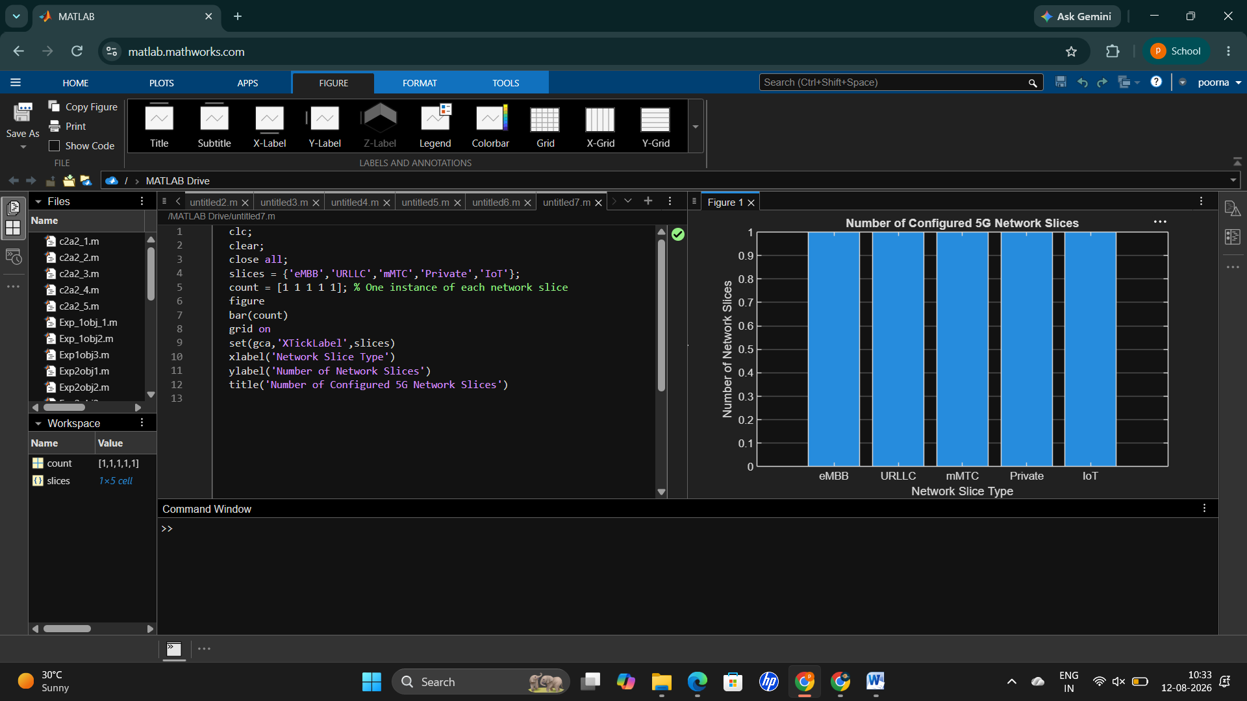
Objective – 2
Compare Slice Utilization (%)
Analyze the utilization percentage of different network slices using MATLAB. Compare the resource usage of each slice to evaluate network efficiency.
MATLAB Code
clc;
clear;
close all;
slices = categorical({'eMBB','URLLC','mMTC','Private','IoT'});
utilization = [85 70 60 75 50];
figure;
bar(slices, utilization);
grid on;
xlabel('Network Slice Type');
ylabel('Slice Utilization (%)');
title('Slice Utilization in 5G Network Slicing');
ylim([0 100]);
Expected Output
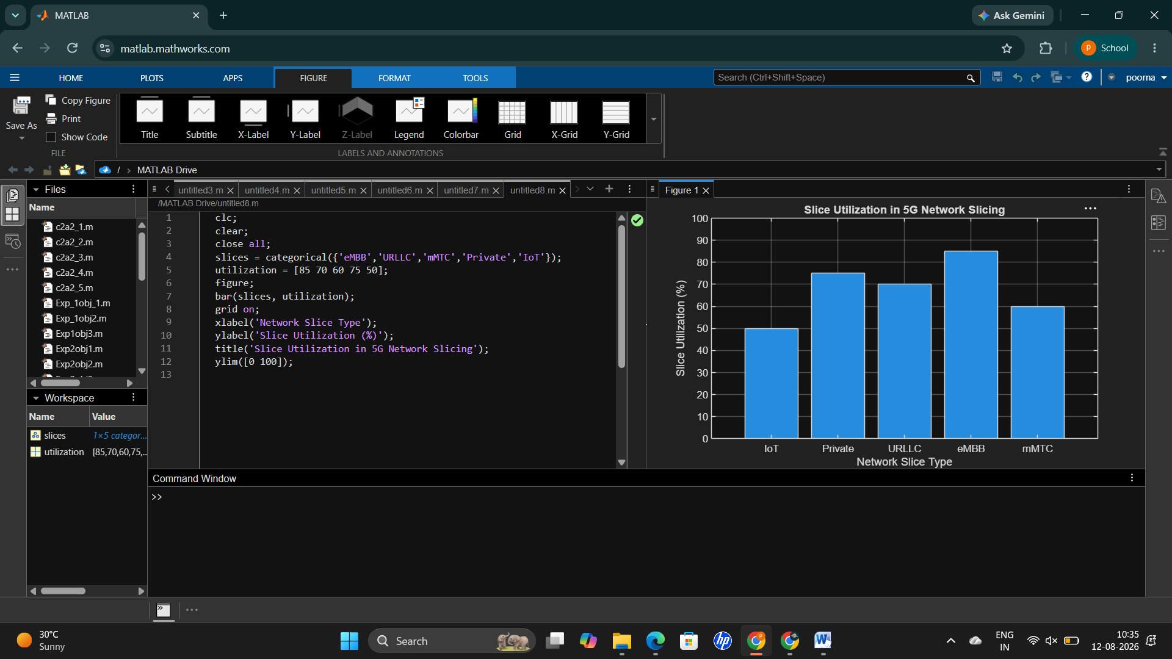 Objective – 3
Analyze End-to-End Latency (ms)
Compare the end-to-end latency of different network slices using MATLAB. Observe how latency varies depending on the service requirements of each slice.
MATLAB Code:
clc;
clear;
close all;
slices = [1 2 3 4 5];
latency = [25 5 40 15 60];
figure;
plot(slices, latency, '-o','LineWidth',2,'MarkerSize',8);
grid on;
xticks(slices);
xticklabels({'eMBB','URLLC','mMTC','Private','IoT'});
xlabel('Network Slice Type');
ylabel('End-to-End Latency (ms)');
title('5G Network Slicing: End-to-End Latency');
ylim([0 70]);
Expected Output
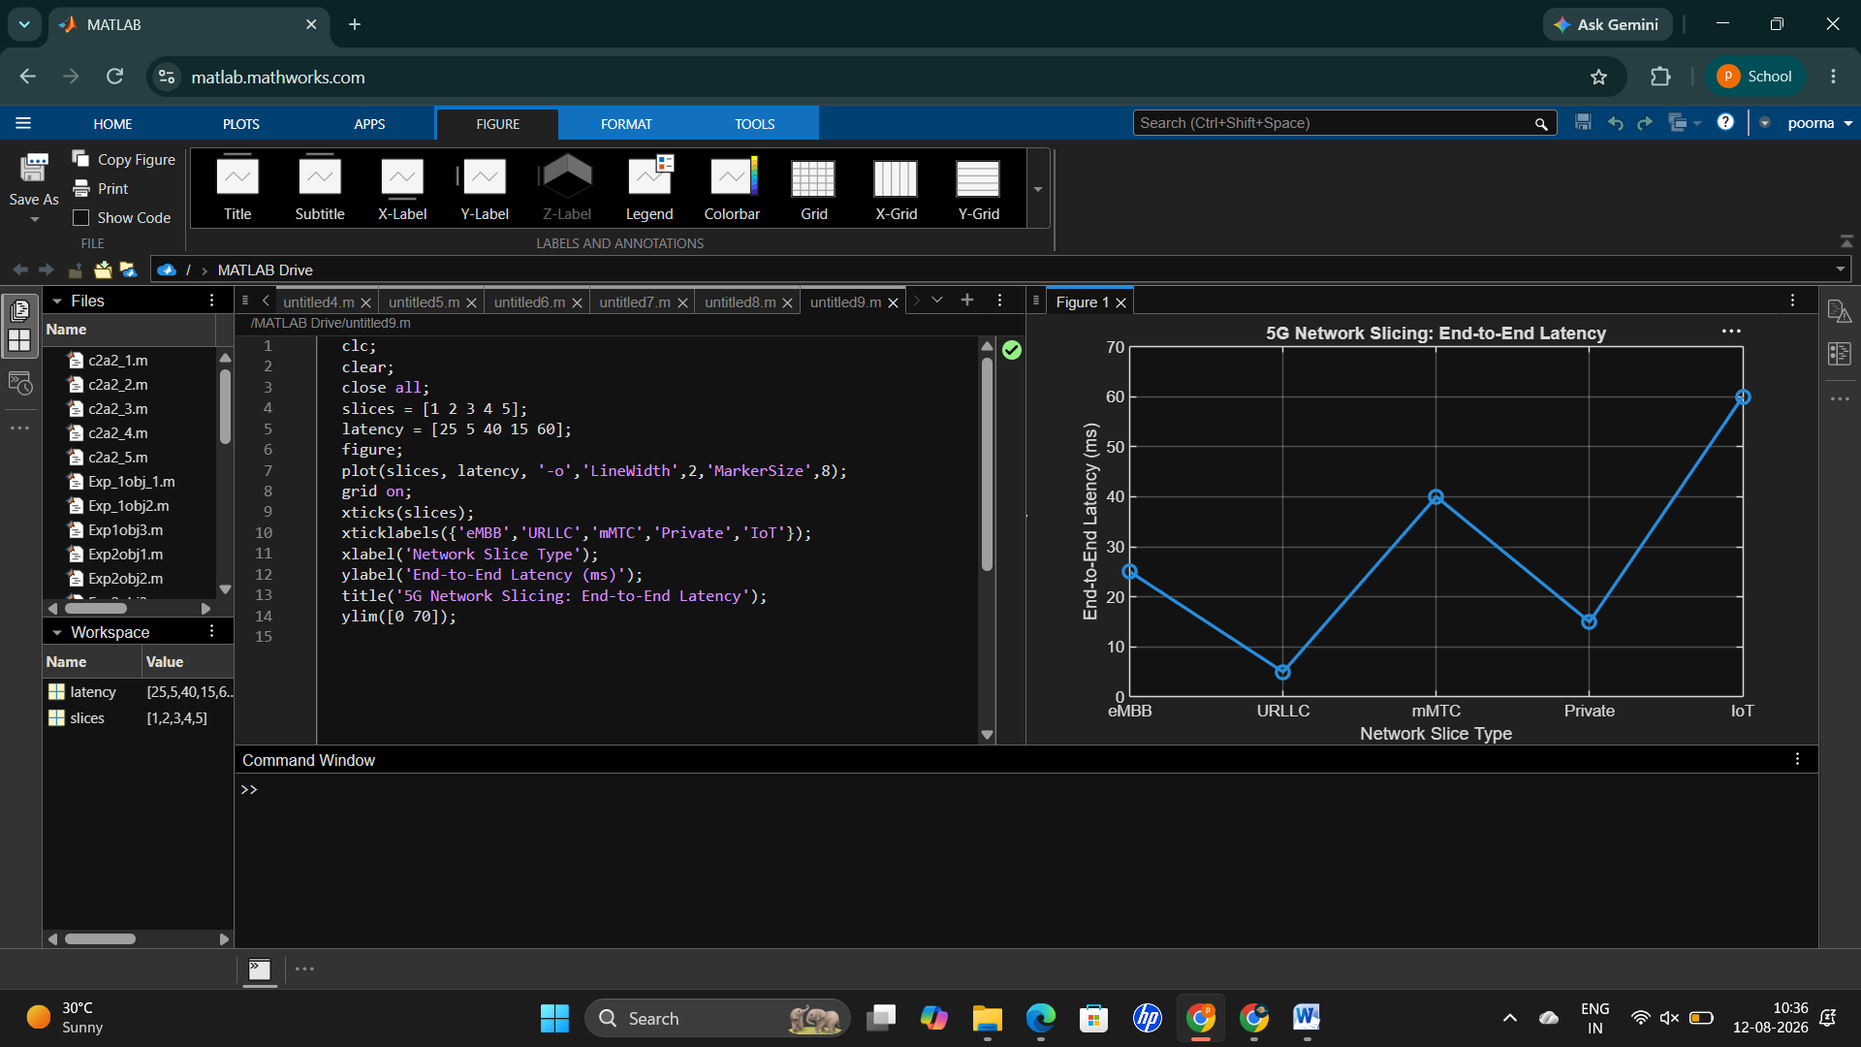
Result :
The MATLAB analysis successfully demonstrated the characteristics of a 5G Network Slicing environment. The results showed that multiple network slices can coexist while exhibiting different utilization levels and latency characteristics based on their intended services.

